

Assignment3&4

Student Name: Wenxu Kang Wen Ma



Student ID:300943385 300903179

Centennial College

Table of Contents

**Type chapter title (level 1)1**

Type chapter title (level 2)2

Type chapter title (level 3)3

**Type chapter title (level 1)4**

Type chapter title (level 2)5

Type chapter title (level 3)6

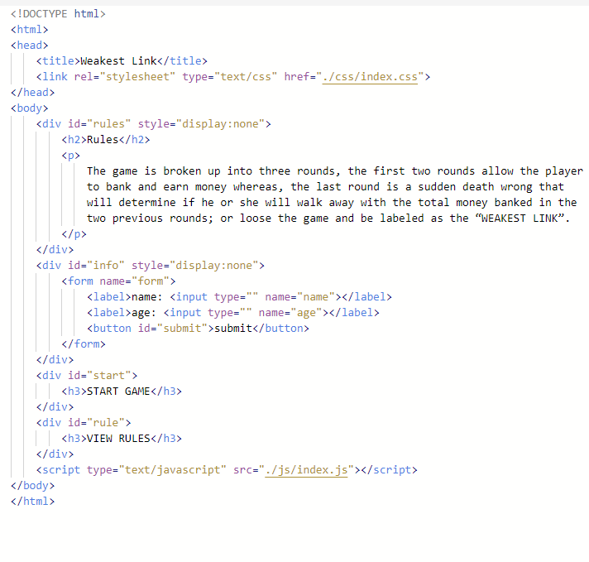

For this screenshot, it Is the index html, the title is weakest link, and there is a button in the index, when user click rules button, it will display the rules words. And there is a start game button, when user click it, it will display two forms, one for type name, one for type age, and when user click submit, the system will display the game.js.

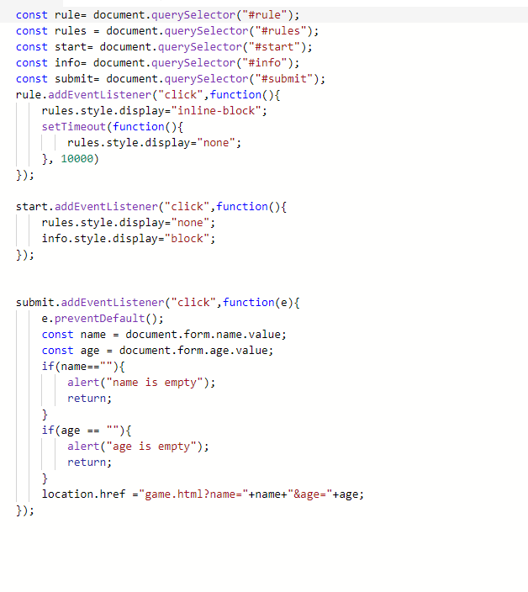

We display the rule and start as click buttons ,after click start button ,it will required name and age,the name and age can not be empty,otherwise it will shows”name/age is empty”

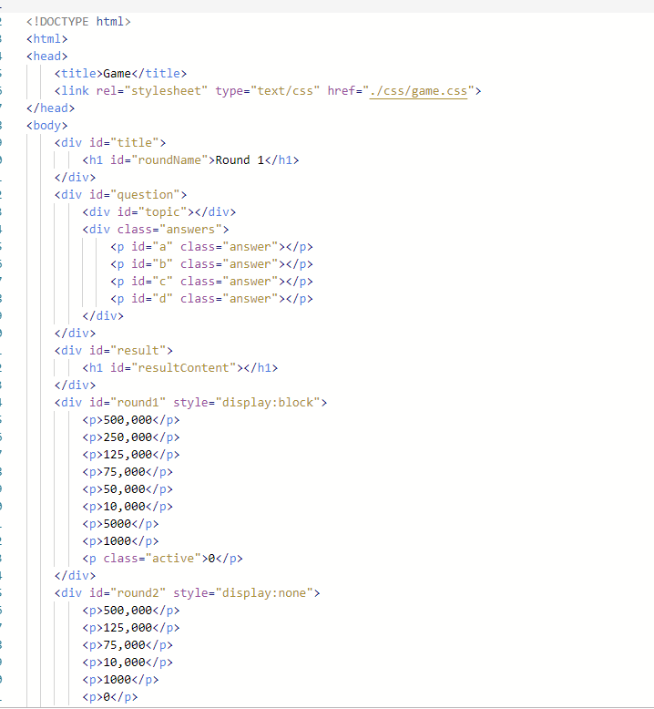

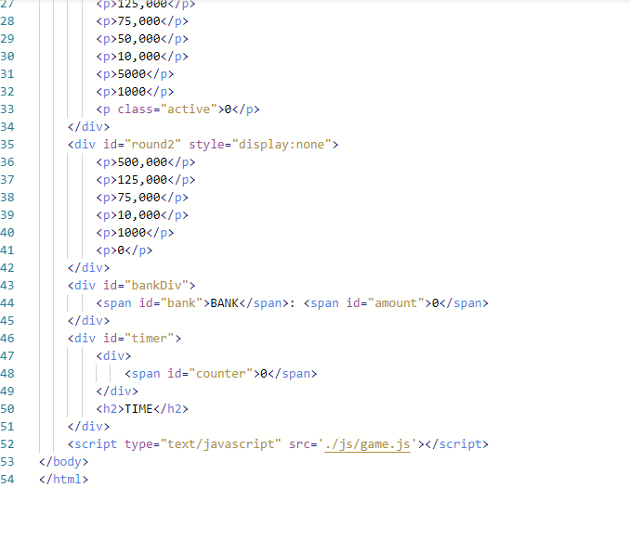

This screenshot for the second html, when people click submit name and age, the system will display the game html. It depends on game.css and limit 4 answers in every round, and limit every amount in every round, in this page bottom, there are two buttons, for bank it can save all money People already get, and timer will display how many time left.

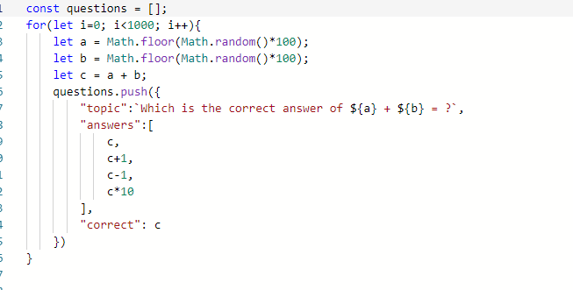

This screenshot from game.js, this is the question bank, all of questions we use math random, and limit 1 is correct answer and random appear, the other wrong choices are +1 , -1, *10.

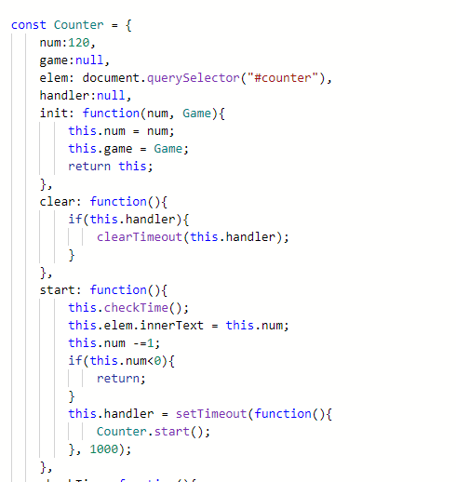

This is the timer function, we set first part time is 120 sec after game start.

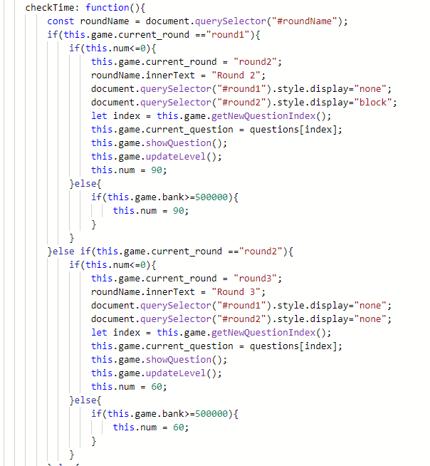

This screenshot shows that if part 1 run out of the time(120sec), it will go to round automatically. Round 2 has 90 sec, if user click bank button, the second part will be 60 sec, after run out of time ,it will go to round 3 automatically.

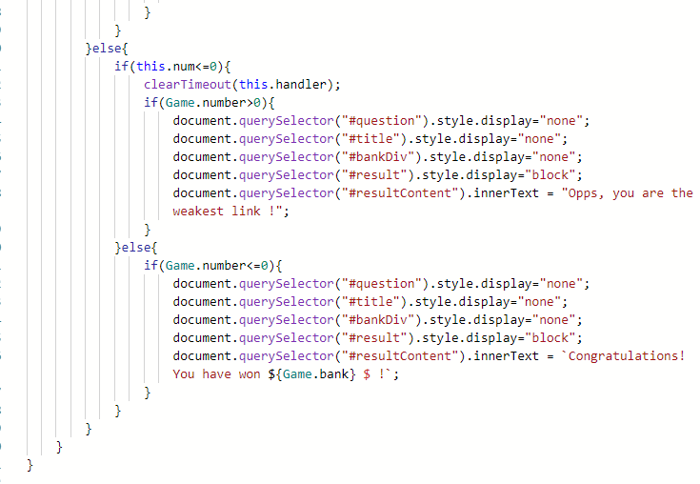

For these three screenshots, we limit counters time is 120s, when time is out it will display opps you are in the weakest link, and if in the last part time is out, it will display congratulations, you won how much money!

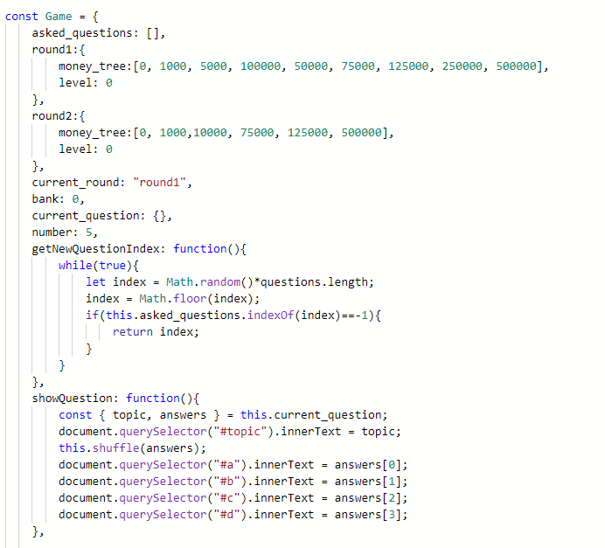

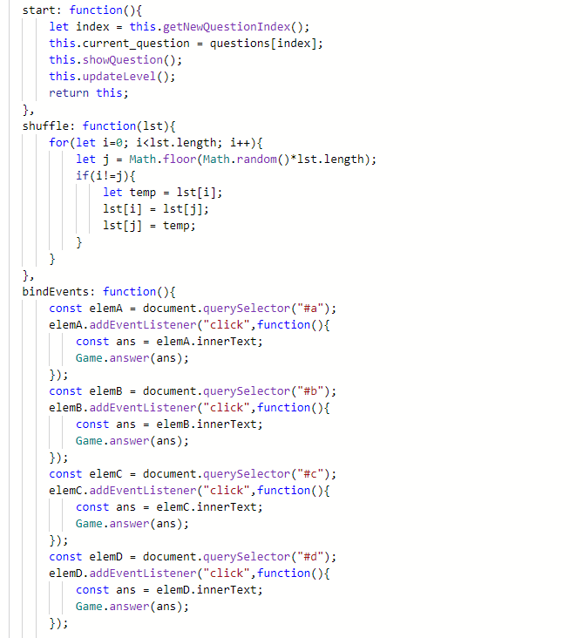

This two screen shot display the choice’s function , Firstly we set the money_tree to match the HTML and the first getNewQuesionIndex function is to make sure the questions will be randomly, and the showQuestion function is to make sure 4 choices match 4 number at the begining, when people click start button, the start function is to match all random function,and the shuffle function is to make sure 4 choices will be randomly.bindEvents function is to make sure 4 choices can be click to choose.

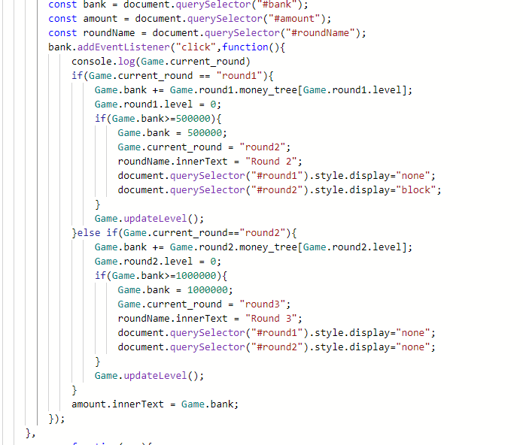

This is the screen shot with “bank”, It will began with $0,when the user win 500000 and select to bank money, it will take user to round 2.Same as before, when user win 1000000 and select to bank money, it goes round 3.

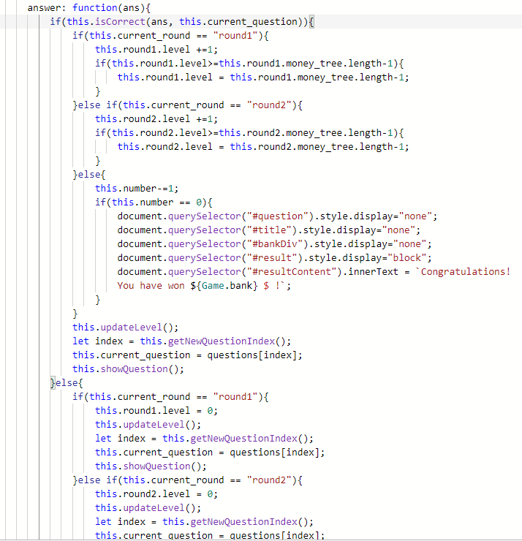

This screen shot display when user answer correct, the money tree level will go up (in round1 and round2).In round3 when user answer 5 questions correct, it will display the result （Congratulations//Oops weakest link）

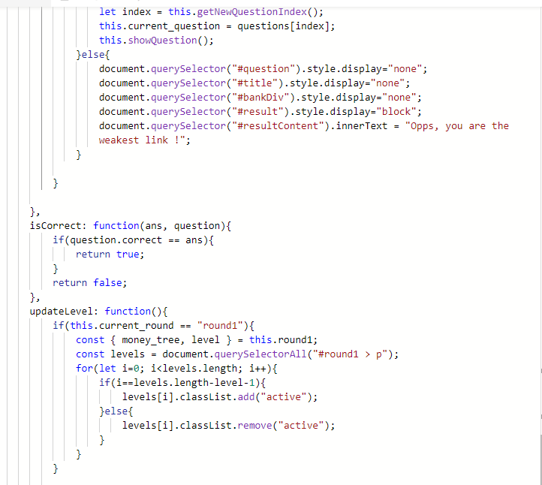

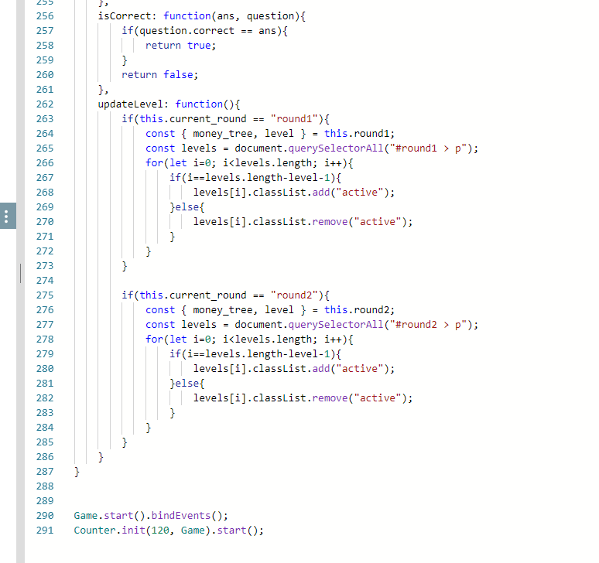

Is correct function is to make sure in round 1 and round 2 when user click right answer the money tree will go up one level, if write wrong, the level will be back to active(0) the P write in CSS file and when people click right answer, the level will be change color like rise.